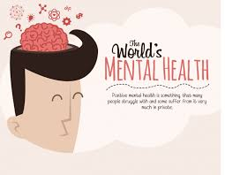



What you can do to Manage Depression

A RESOURCE PACKET FOR DEPRESSION
What you can do to manage depression
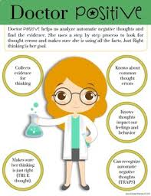
Exercise | Eat Healthy | Challenge Negative Thoughts
By doing exercises it boosts production of feel-good chemicals known as endorphins. By carrying out exercises on a regular basis seems to encourage the brain to rebuild itself in a more positive perspective (Maisel, 2012). | There is no any kind of mix of foods that fixes depression. However, an individual should watch out so as to feed better. If depression tends to make an individual to take much food, then getting control of the eating habits will assist the person to feel better (Maisel, 2012). | Much of the work that is done when an individual is trying to fight against depression is mental. Thus, a person should challenge how he or she thinks. When a person is feeling depressed, he encounters terrible feelings about himself (Bloch & Bloch, 2009). In such a case, the person should use logic as a natural depression treatment.

Websites the person can visit:

American Psychiatric Association | Mental Health America | National Institute of Mental Health
This website is resourceful as it provides the patients among other people with the kind of information that they might require dealing with depression among other mental issues. The website outlines information concerning signs/symptoms, risks among other related information.  Link: https://www.psychiatry.org/patients-families/depression/what-is-depression | This website outlines all the necessary information that might be required concerning depression among other related mental illnesses. It outlines basic facts about depression, it causes, symptoms, types of depressions and ways through which it can be addressed.  Link: https://www.mentalhealthamerica.net/conditions/depression | This website is rich in information concerning depression among other mental illnesses. It provides information concerning how depression affects people and the different ways through which it can be treated.  Link: https://www.nimh.nih.gov/health/publications/depression-what-you-need-to-know/index.shtml

Local mental health agencies:

Hamilton Center, INC. | Mental Health Association in Vigo County INC.
The organization is established to deal with behavioral health serving central and west central Indiana. The organization serves people of all ages ranging from children, adults, adolescents and even families. Their services are individualized, trauma informed, and evidence-based.  Link: http://www.hamiltoncenter.org/locations/vigo-county/  Location: 620 Eighth Avenue  Terre Haute, IN 47804  (800) 742-0787 | The organization was set up to promote mental health within the general public. It advocates for better services for those who have mental illnesses and also work towards prevention of such illness in the Vigo County, Indiana.  Location: 1460 Spruce Street  Terre haute, IN 47807  Link: https://www.guidestar.org/profile/20-8762173  Contact: 8033392382

Mental health/Depression books:
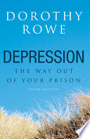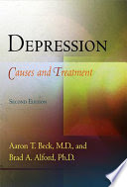
Depression: The Way Out of Your Prison | Depression: Causes and Treatment | Depression
This book is written by Dorothy Rowe and it shows that depression is not an illness but a defence against fear and pain. This is the kind of defense that many people find themselves employing whenever they go through life challenges and discover that their life is not what they thought it was.  Publisher: Routledge  ISBN: 978-1-58391-286-7  Link: https://books.google.co.ke/books?id=tPP0u8FBvBEC&printsec=frontcover&dq=depression&hl=en&sa=X&ved=0ahUKEwj61JeIx97hAhVQOhoKHbkKBOEQ6AEILjAB#v=onepage&q=depression&f=false | This is the second edition and it provides information concerning the diagnosis, causes, and treatment of depression; it addresses both the use of psychological and biological approaches in curing depression.  Authors: Aaron T. Beck, M.D., and Brad A. Alford, Ph.D.  Publisher: University of Pennsylvania Press  ISBN: 978-0-8122-1964-7  Link: https://books.google.co.ke/books?id=Ntw8AwAAQBAJ&printsec=frontcover&dq=depression&hl=en&sa=X&ved=0ahUKEwj61JeIx97hAhVQOhoKHbkKBOEQ6AEIOjAD#v=onepage&q=depression&f=false | This book is entirely talking about depression: its causes and how it can be prevented.  Author: Raymond W. Lam, MD, FRCPC  ISBN : 978-0-19-969273-6, second edition.  Publisher:  Link: https://books.google.co.ke/books?id=1Hbjf7kS0KgC&printsec=frontcover&dq=depression&hl=en&sa=X&ved=0ahUKEwj61JeIx97hAhVQOhoKHbkKBOEQ6AEIQTAE#v=onepage&q=depression&f=false

References
Beck, A. T., & Alford, B. A. (2009). Depression: Causes and treatments. Philadelphia: University of Pennsylvania Press.
Bloch, D., & Bloch, D. (2009). Healing from depression: 12 weeks to a better mood : a body, mind, and spirit recovery program. Fort Worth, FL: Nicolas-Hays, Inc.
Lam, R. W. (2012). Depression. Oxford: Oxford University Press.
Maisel, E. (2012). Rethinking depression: How to shed mental health labels and create personal meaning.
Moragne, W. (2011). Depression. Minneapolis, MN: Twenty-First Century Books.

